**Lab Assignment-2 Report**

I have created a Mobile web application using JSfiddle, HTML, JavaScript, CSS for my Lab Assignment-2.

This application can be used by the user for getting the directions from any given source to destination. This application also implements the use of Google Maps for providing the Direction Services for the users request.

1. This is the home page of my mobile web application. The user can retrieve his/her directions by clicking the Show Directions button.

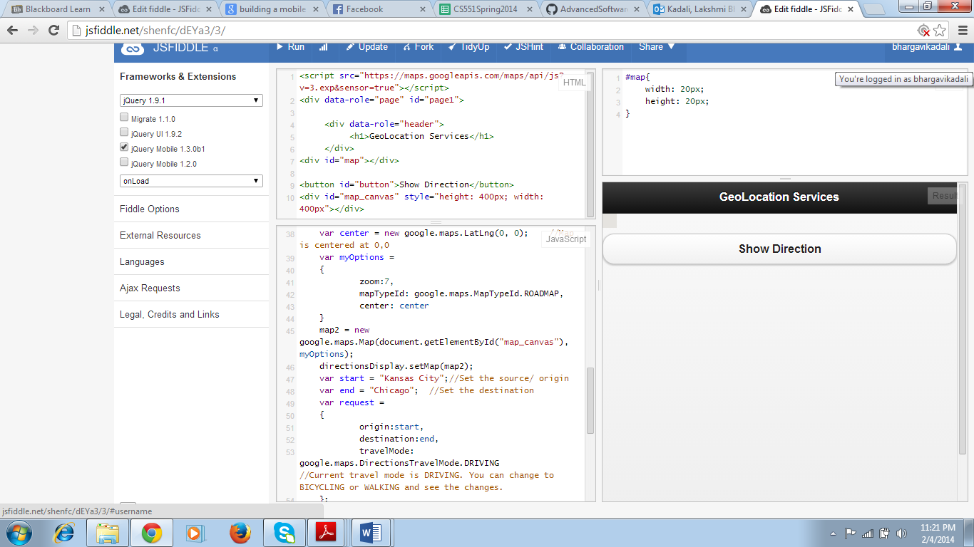

1. After clicking Show Directions Button, the directions from Source to the Destination (Specified by the user) are shown here.

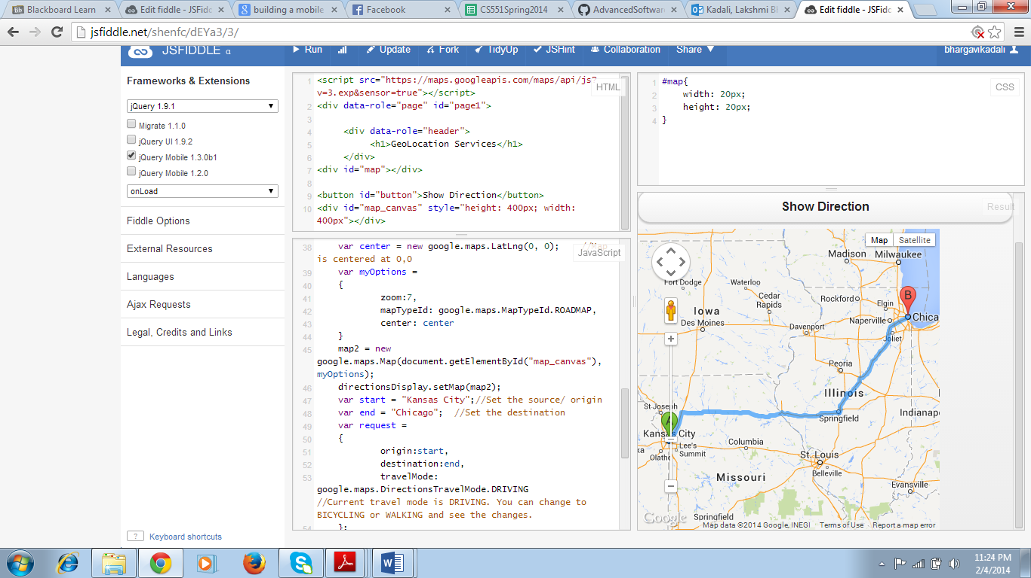

1. The user also has the option of zooming the directions using this application.

